|  |  |  |  |
| --- | --- | --- | --- |
| 1 | | 19,095.428571428572 | |
| NUMERO DE FRONTERAS | | ENERGIA AGREGADA | |
|  | | | |
| NO | | 0 | |
| CONTRATO | | VENCIMIENTO CONTRATO | |
|  | | | |
| 6,802,134 | 13 | | 0 |
| INGRESO 2019 | DÍAS CERTIFICADOS 2019 | | ENERGIA RESPALDADA 2019 |
|  | | | |
| 66,019,147 | 156 | | 2,382,222 |
| INGRESO 2020 | DÍAS CERTIFICADOS 2020 | | ENERGIA RESPALDADA 2020 |
|  | | | |
| 38,291,283 | 108 | | 1,666,201 |
| INGRESO 2021 | DÍAS CERTIFICADOS 2021 | | ENERGIA RESPALDADA 2021 |

|  |
| --- |
| **CARTAGENA HILTON**  USUARIO |

|  |
| --- |
| **Edwin Torres**  Ejecutivo de cuenta |

|  |
| --- |
| **0**  Primera fecha: PUNTO FOCAL |

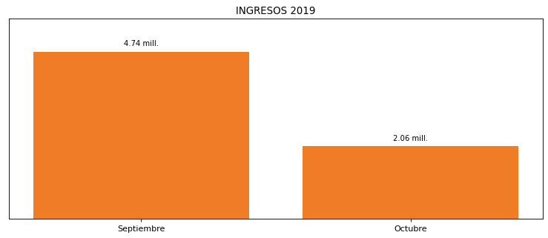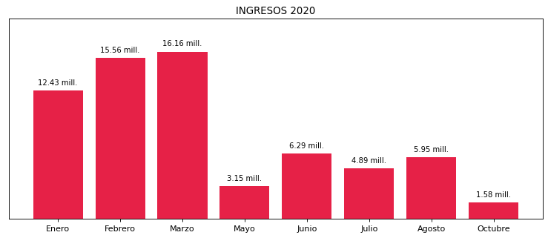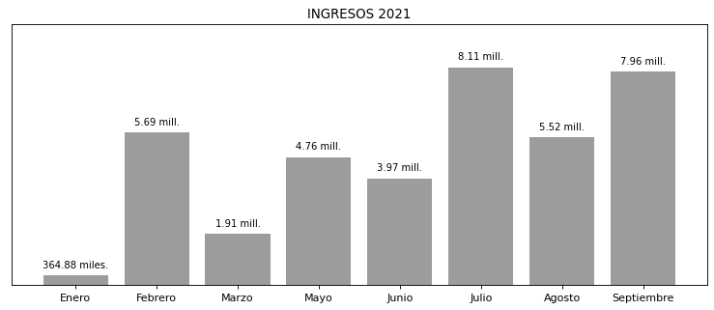

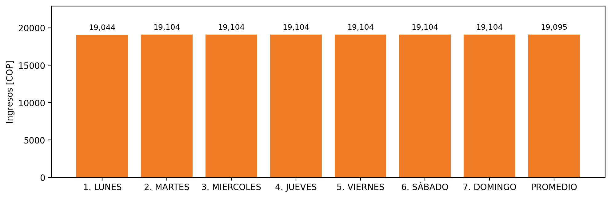

|  |  |  |  |  |  |  |  |  |  |
| --- | --- | --- | --- | --- | --- | --- | --- | --- | --- |
| **FRONTERA COMERCIAL** | **TIPO DDV** | **COD SIC** | **PREDIO** | **PROMEDIO** | **MARGEN** | **ÚLTIMA DESCONEXION** | **DÍAS CERTIFICADOS** | **ACTUALIZACION** | **PROXIMA PRUEBA DDV** |
| CARTAGENA HILTON | Frt32733 | Frt10361 | Prd01286 | 19,095 | 3,77 | 2021-09-01 | 18.0 | 2021-12-09 | 2022-01-21 |